**Tplink Extender Setup**

Wish to set up tp link extender, but not sure about the exact steps to do it?

Follow this guide, and know all about the [**tplink extender setup**](https://www.tplinkextender-net.net/)with tplinkextender.net web address.

TP-Link WiFi extenders fill up the poor or dead wifi zones. When your router fails to cover those farthest corners of your place then it is an indication that you should get a tp-link repeater. Tp-link extender takes the signal from the existing router and then circulate them over a larger area. Contact our experts if tplink extender not workingproperly.

Tplinkextender.netsetup does not require much of your efforts or time. You can log into tplink loginpage via [**tplinkrepeater.net**](https://tp-linkrepeatr.net/)to easily configure the device. Just follow the following steps and extend your home network using tplink repeater. So, let’s dive in:

**Quick steps for Tplink Extender Setup**

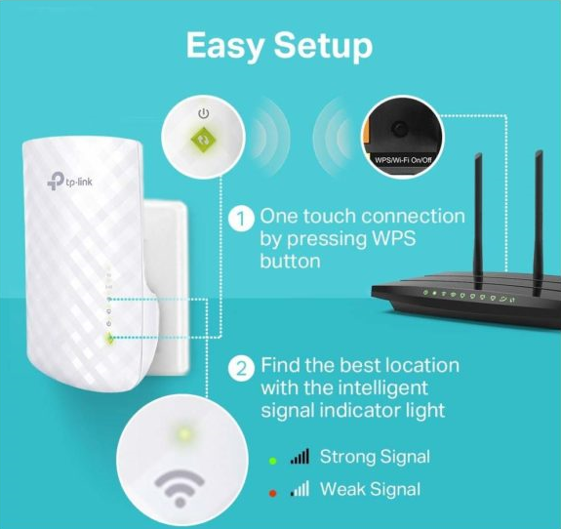

You don’t need an internet connection to get into [**tplink range extender setup wizard**](https://tplinkextendernet.net/). You only require to connect your laptop to the tplink network through the wireless or wired method. This guide is made to teach you the correct steps on how to set up tplink repeater with **tplinextender.net** properly.

**Things you would require:**

* An existing network’s SSID and WiFi password
* Your laptop must be connected tplink network
* Extender must be placed in the same room as the router

After meeting these requirements, you can jump to the tplinkextender.net setup process. Using the default web address, you can get into tplink setup page. Refer to the following points for [**tplink extender login**](https://tplinkrepeater.in/).

**Step 1-** Place your tplink extender in close proximity to wireless router for the configuration and installation stage. Now, plug it in to the nearby power outlet. Press the power button on your device and wait for it to boot up. Proceed when you witness a solid power light.

**Step 2**- Connect the Wi-Fi device that you’re using for the installation part to the tplink network. Go to the ‘Wi-Fi ‘ tab and connect to the tplink wireless network. You may find the SSID and password on the user guide or product label itself.

**Step 3-** Pull up the latest version of the internet browser. Type tplinkextender.netor tplinkrepeater.net. Make sure you’re typing the web address into the address bar and not in the search box. Both the web addresses will direct you to the [**tplink login page**](https://tp-linkrepeatr.net/192-168-0-254-admin-wireless-settings/).

**Step 4-** Fill in the tplink extender login username and password. If the details are correct, tplink range extender setup wizardwill open up on the screen. Click on the ‘Get started’ button.

**Step 5**- The tplink setup pagewill display you with the list of available nearby networks. You need to find and select your home router network by identifying its SSID. Use the router’s wifi password to connect to tplink network. Click on the ‘Next’ option.

**Step 6-** For the next step, you would be asked if you want to change the wireless settings of your tplink device or not. Enter the SSID and password for tplink network. Make sure you press on the ‘Save’ button to apply the changes.

**Step 7-** When you’re done with the [**tplinkextender.net setup**](https://www.tplinkrepeaternet.us/), your extender will go into the reboot phase. Once the extender reboots, you can place it to another location and connect your Wi-Fi devices to newly extended network.

**Ideal Placement of Tplink Extender**

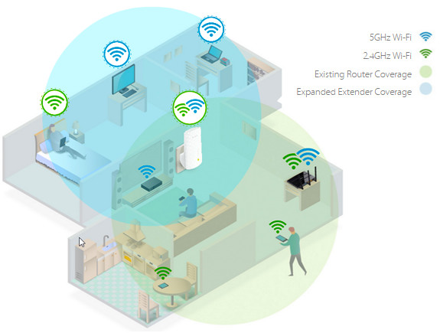

When you’re done with the tplink extender setup, you need to re-locate your device. The placement of an extender plays an important factor. If you’ve placed your device in the far most corner of your home then you will experience disturned signals. Therefore, the central location is considered to be the best for placing tplink extender.

**Troubleshooting: Tplink extender not working**

If you are unable to get into tplink login page with tplinkextender.netor [**tplinkrepeater.net**](http://tp-linkrepeaters.net/), then you can check out the following troubleshooting methods.

**Solution 1-** Make sure you have entered the correct tplink login details. Cross-check the admin username and password. Verify, the default web address for tplink extender

**Solution 2-** Power cycle your device. Turn off your extender for a few minutes. Turn it back on and check if you can access tplink extender loginpage or not.

**Solution 3-** In case, your tplink extender not working, you would need to reset your device to its default settings.

**Troubleshooting- How to reset tplink extender?**

When you’re unable to open [**tplink extender setup page**](https://www.httptplinkrepeater.com/), you would have to reset your device. To reset tplink device, long-press the reset key with the help of a sharp object for a few seconds. Your tplink device will now reset to its default settings.

If you want to ask more about tplink extender setup, you can get back to us by calling on our toll-free number.